|  |
| --- |
| SENG 403: Software Development in teams and organizations |
| Iteration #2 Report |
| Group 4 |
|  |
| **James Bertram, Thomas Frampton, Ekaterina Grekova, Matthew Jones, Andrew Midwinter, Mark Mullen** |
| **3/26/2012** |

|  |
| --- |
|  |

Contents

Summary 2

Progress during Iteration 2 2

Weekly Snapshot of the Storyboard 3

Plan for Iteration 3 5

Work Distribution 6

Appendix A – Stories 8

# Figures

Figure 1. Velocity during iteration 1, 2 and 3 2

Figure 2. Storyboard snapshot at the beginning of week 1 in Iteration 2 3

Figure 3. Storyboard snapshot at the beginning of week 2 in Iteration 2 4

Figure 4. Storyboard snapshot at the beginning of week 3 in Iteration 2 4

Figure 5. Storyboard snapshot at the beginning of week 4 in Iteration 2 5

# Tables

Table 1. Stories with their priority and points 7

# Summary

The report presents the deliverables of Iteration 2 and planned work for Iteration 3. The work progress during Iteration 2 is present in the Weekly Snapshot of the Storyboard section. After discussions among the group and with the customers, the plan for Iteration 3 was developed, and it is presented in this report. The tasks were managed in a fair manner and appropriate feedback was provided to the group members. Also, we focused on improving group communications by being more responsive and notifying others more efficiently of the tasks that are in progress and are completed.

# Progress during Iteration 2

The following features were completed during Iteration 2 and are ready for user testing:

* Feature 1.1
* Feature 1.3
* Feature 1.4
* Feature 2.1
* Feature 3.1

Additional information on stories is provided in Appendix A.

Each story has points which are represented in terms of days (1 average SENG403 work day). Figure 1 illustrates the graph with the velocity during iteration 1, 2 and 3. The velocity for iteration 3 was estimated and it is an average velocity of iteration 1 and 2.

Figure . Velocity during iteration 1, 2 and 3

## Weekly Snapshot of the Storyboard

During Iteration 2, different tasks were assigned to group members. We discussed those tasks and upon completion, we provided each other with the feedback for further improvements. The following snapshots of the storyboard illustrate how the project was progressing during Iteration2. The snapshots were taken at the beginning of each week.

Figure . Storyboard snapshot at the beginning of week 1 in Iteration 2

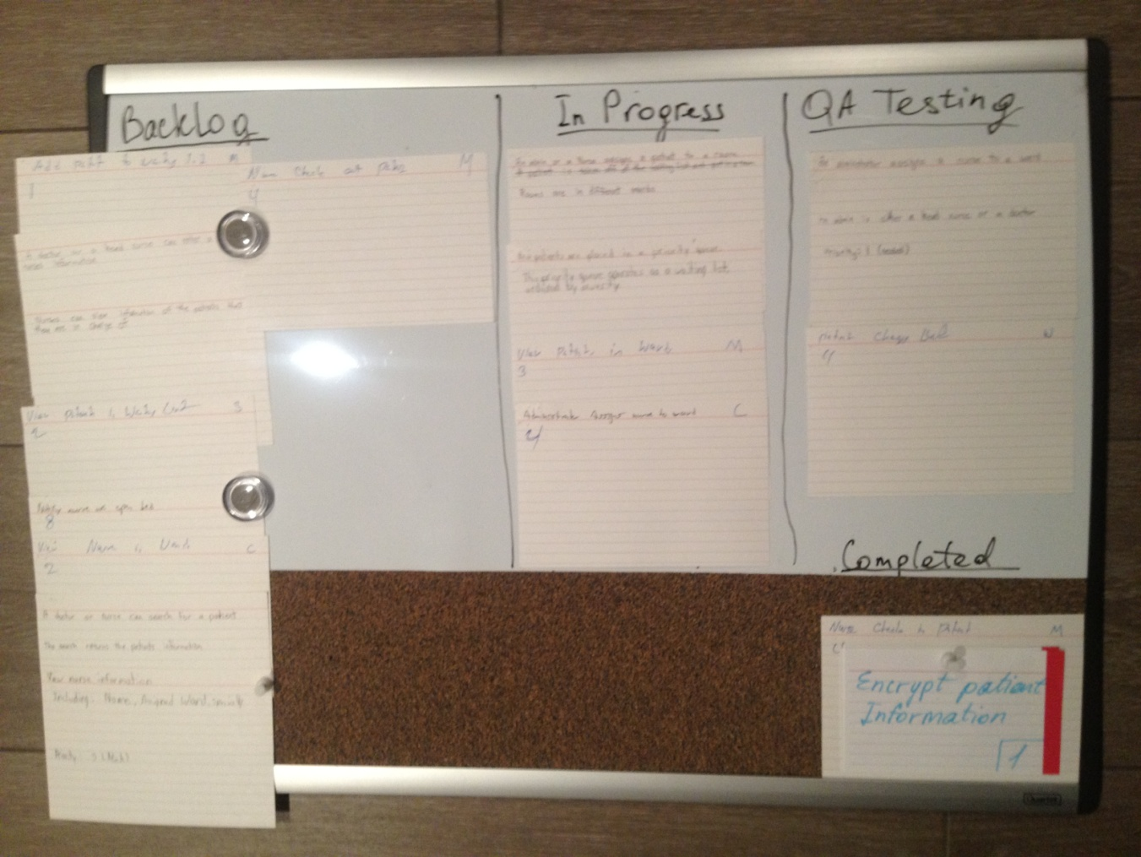

Figure . Storyboard snapshot at the beginning of week 2 in Iteration 2

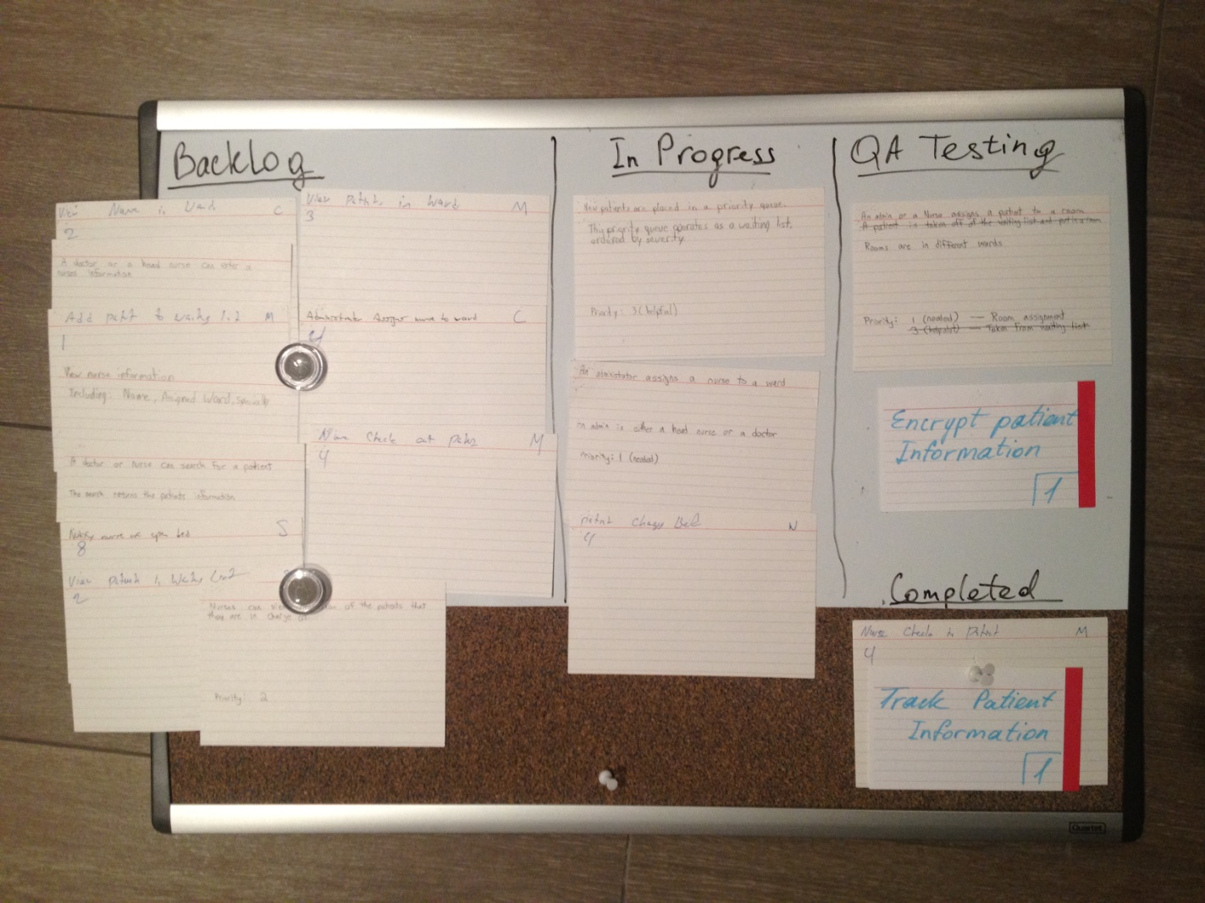

Figure . Storyboard snapshot at the beginning of week 3 in Iteration 2

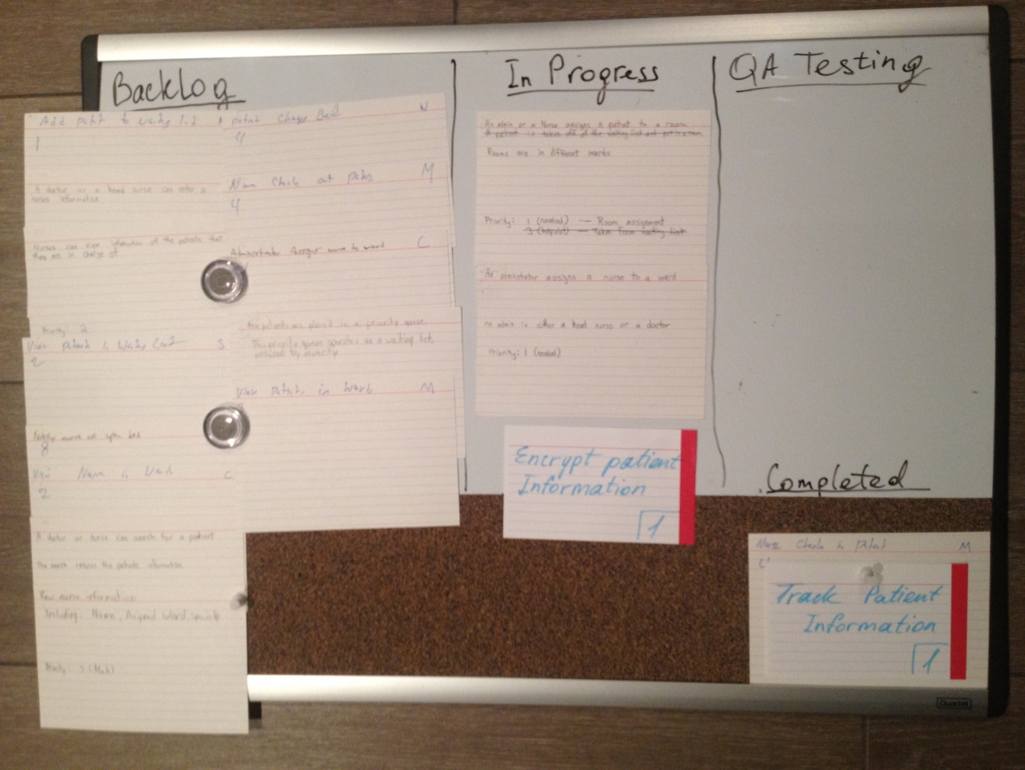

Figure . Storyboard snapshot at the beginning of week 4 in Iteration 2

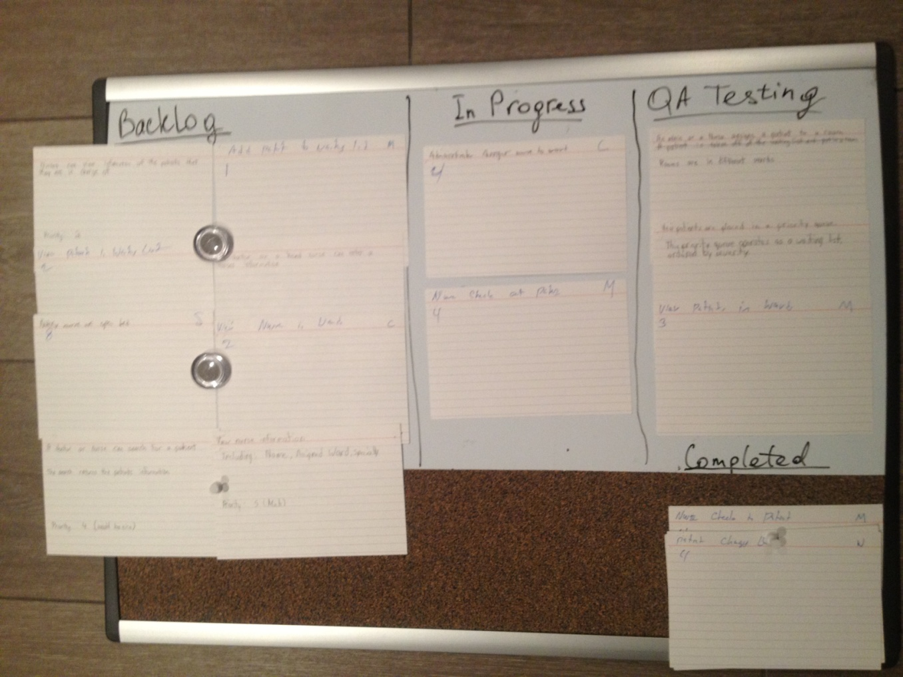

# Plan for Iteration 3

During the iteration planning meeting, which was conducted prior to the end of Iteration 2, we determined the plan for Iteration 3. The plan was confirmed with the customers. Also, we considered the estimated velocity for the Iteration 3. Below is the developed plan:

* Resolve defects identified in Iteration 2
* Implement feature 1.5
* Implement feature 4.1
* Implement feature 5.1

Additional information on stories is provided in Appendix A.

# Work Distribution

**Thomas**

Tasks:

* + Assign nurses to wards
  + Encrypt patient information

Stories:

* + Administrator assigns nurse to ward
  + Encrypt patient information

**Mark**

Tasks:

* + Track rooms and beds
  + Assign patients to rooms and beds
  + Critique the suppliers report

Stories:

* + Patient changes beds
  + View patients in ward

**Andrew**

Tasks:

* + Create nurse
  + Edit nurse
  + Delete nurse

Stories:

* + Track nurse information

**Matthew**

Tasks:

* + Place patients in a priority queue
  + Improve usability of Login screen (button listeners, etc.)
  + Code refactoring (moved different logic to appropriate classes)

Story:

* + Admin or nurse assign can assign patient to a room

**Ekaterina**

Tasks:

* + Create/edit UI
  + QA testing
  + Write the report
  + Check-in and check-out patients

Stories:

* + Nurse can checkout patient

**James**

Tasks:

* + Delete patient
  + Assign patients to rooms and beds

Stories

* + Patient changes beds
  + View patients in ward
  + Admin or nurse assigns a patient to a room

# Appendix A – Stories

Table . Stories with their priority and points

|  |  |  |  |
| --- | --- | --- | --- |
| **Number** | **Story** | **Priority** | **Points** |
| **1.1** | Assigning patients to rooms (This feature allows nurses or administrators to assign patients to specific rooms.) | **1** | **3** |
| **1.2** | Tracking Patient Information (This feature allows administrators to enter, edit, and view information about patients.) | **1** | **4** |
| **1.3** | Tracking Bed/Room availability (This feature keeps track of which beds and rooms are currently available, and which are currently occupied.) | **1** | **5** |
| **1.4** | Assigning Nurses to Wards (This feature allows administrators to assign nurses to wards.) | **1** | **3** |
| **1.5** | Encrypting of Patient Information (Patient information will be encrypted for security.) | **1** | **1** |
| **2.1** | Tracking Nurse Information (Doctors and head nurses can enter, edit nurses' information.) | **2** | **4** |
| **3.1** | Placing Patients in a Priority Queue (Patients will be placed in a priority queue to order them by the severity of their illness or injury.) | **3** | **5** |
| **4.1** | Searching for Patients (Nurses and Doctors can search for information about a specific patient.) | **4** | **3** |
| **5.1** | Scheduling Nurses (Administrators can create schedules to assign nurses to shifts.) | **5** | **5** |